**DATA VISUALIZATION**

**Ex.No. :6 230901039**

**Date :25-03-2025**

**AIM:**

To import data visualization packages and do the basic functions.

**SOFTWARE USED:**

Jupyter notebook

**DATA VISUALIZATION-1**

**DESCRIPTION:**

1. Get the x axis and y axis points through numpy array and plot the line.
2. Plot the points without line using marker options.
3. Multiple points options can also be plotted.
4. Using default x axis value by specifying any y axis value, we can plot points.

**PROGRAM:**

**import** matplotlib.pyplot **as** plt

**import** numpy **as** np

xp**=**np**.**array([0,10])

yp**=**np**.**array([20,100])

print(plt**.**plot(xp,yp))

print(plt**.**show())

x**=**np**.**array([0,5])

y**=**np**.**array([0,25])

print(plt**.**plot(x,y,marker**=**'p'))

print(plt**.**show())

x**=**([1,2,6,8])

y**=**([3,8,1,10])

print(plt**.**plot(x,y))

print(plt**.**show())

y**=**np**.**array([5,7,1,0,3])

print(plt**.**plot(y))

print(plt**.**show())

x**=**np**.**array([3,8,1,4,9])

y**=**np**.**array([5,7,1,0,3])

print(plt**.**plot(x,y))

print(plt**.**show())

**OUTPUT:**

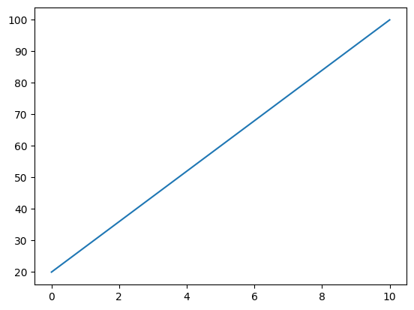

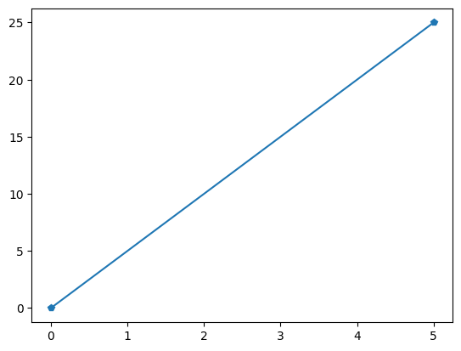

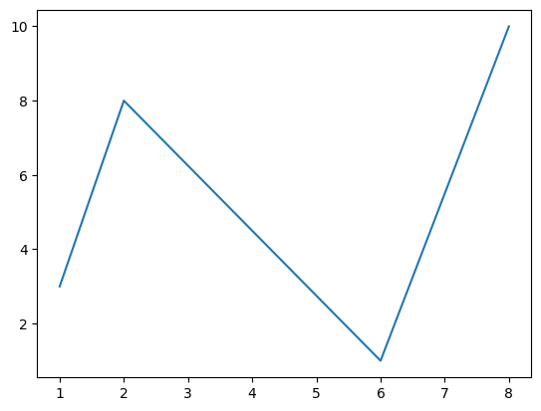 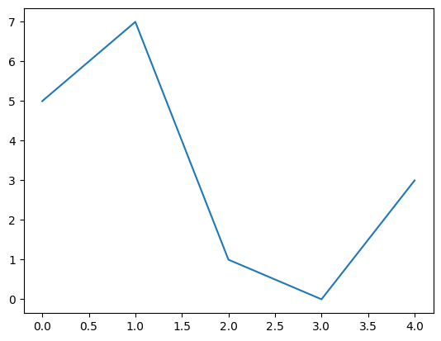 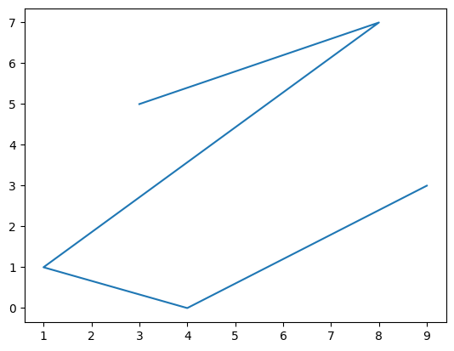

**DATA VISUALIZATION-2**

**DESCRIPTION:**

1. Use title, X-axis and Y-axis labels.
2. Use line style, colors and line width.
3. Use multiple lines with grid options.
4. Use sub-plots options.
5. Use scatter options: Single coordinates,Double coordinates.

**PROGRAM:**

**import** matplotlib.pyplot **as** plt

**import** numpy **as** np

*#Title and label*

ypoints **=** np**.**array([3, 8, 1, 10, 5, 7])

print(plt**.**plot(ypoints, linestyle**=**'dashed'))

plt**.**title('Sample graph')

plt**.**xlabel('X axis')

plt**.**ylabel('Y axis')

print(plt**.**show())

*#Marker,color,Linewidth*

ypoints **=** np**.**array([3, 8, 1, 10, 5, 7])

print(plt**.**plot(ypoints, marker **=** 'o'))

print(plt**.**show())

xpoints **=** np**.**array([0, 6])

ypoints **=** np**.**array([0, 250])

print(plt**.**plot(xpoints, ypoints, 'violet'))

print(plt**.**show())

print(plt**.**plot(xpoints, ypoints, linewidth**=**'30', color**=**'c'))

print(plt**.**show())

*#Multiple lines and grid*

y1 **=** np**.**array([3, 8, 1, 10])

y2 **=** np**.**array([6, 2, 7, 11])

print(plt**.**plot(y1))

print(plt**.**plot(y2))

plt**.**grid()

print(plt**.**show())

x **=** np**.**array([0,1,2,3,4,5])

y **=** np**.**array([3,8,1,10,9,4])

plt**.**subplot(1,2,2)

plt**.**plot(x,y)

x**=** np**.**array([1, 2, 6, 8])

y**=** np**.**array([3, 8, 1, 10])

plt**.**subplot(1,2,2)

plt**.**scatter(x, y)

plt**.**show()

a**=**np**.**array([5, 7, 9,10])

b**=**np**.**array([2, 5, 8,2])

plt**.**scatter(a,b)

plt**.**show()

**OUTPUT:**

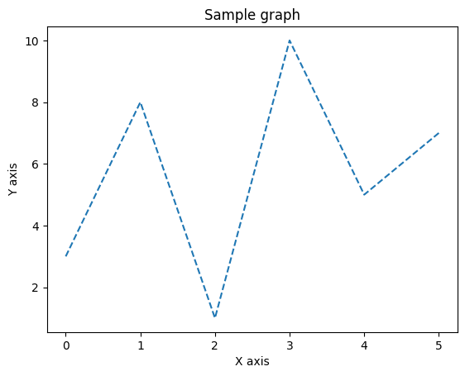 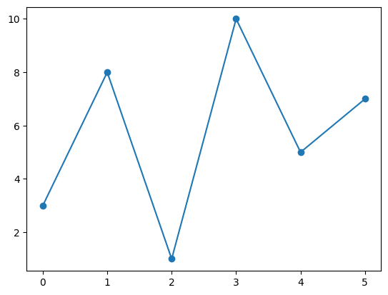 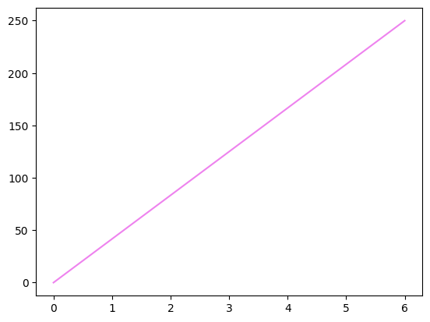 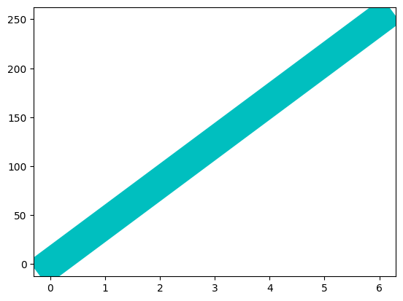 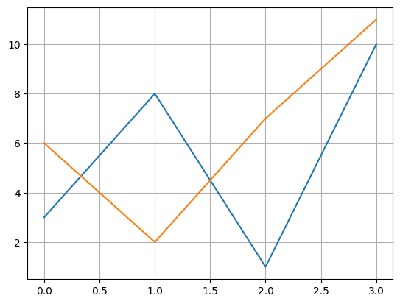 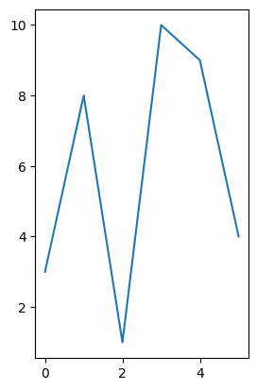 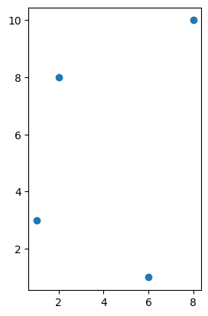 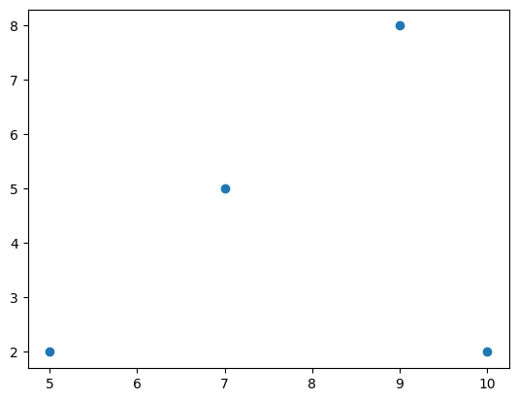

**DATA VISUALIZATION-3**

**DESCRIPTION:**

1. Draw bar chart

2. Draw multi-bar chart with title x and y labels

3. Draw horizontal bar

4. Use color and width options

5. Draw histogram

6. Draw pie chart: without label, with label, with explode

**PROGRAM:**

**import** matplotlib.pyplot **as** plt

**import** numpy **as** np

x **=** np**.**array(["A", "B", "C", "D"])

y **=** np**.**array([5, 7, 2, 15])

plt**.**bar(x,y)

plt**.**show()

plt**.**bar([0.5,2.5,4.5,6.5,8.5],[50,40,70,80,20],

label**=**"BMW",width**=**1)

plt**.**bar([1.5,3.5,5.5,7.5,9.5], [80,20,20,50,60],

label**=**"Audi", color**=**'c', width**=**1)

plt**.**legend()

plt**.**xlabel('Days')

plt**.**ylabel('Distance (kms)')

plt**.**title('Information')

plt**.**show()

plt**.**barh(x,y)

plt**.**show()

plt**.**bar(x,y, color**=**'red')

plt**.**show()

plt**.**bar(x,y, color**=**'g', width**=**0.1)

plt**.**show()

x **=** np**.**random**.**normal(300, 20, 250)

plt**.**hist(x)

plt**.**show()

y **=** np**.**array([40, 30, 20, 10])

plt**.**pie(y)

plt**.**show()

*#With Labels*

y **=** np**.**array([35, 25, 25, 15])

mylabels **=** ["MPMC", "PPML", "ContolSystem", "PSA"]

plt**.**pie(y, labels **=** mylabels)

plt**.**show()

y **=** np**.**array([35, 25, 25, 15])

mylabels **=** ["MPMC", "PPML", "ContolSystem", "PSA"]

myexplode **=** [0, 0, 0.3, 0]

plt**.**pie(y,labels**=**mylabels,explode**=**myexplode)

plt**.**show()

**OUTPUT:**

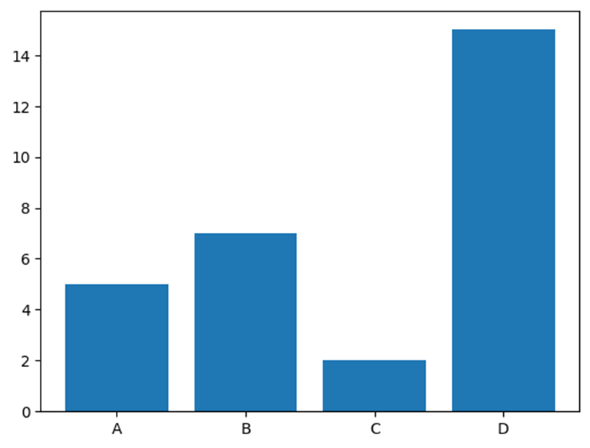

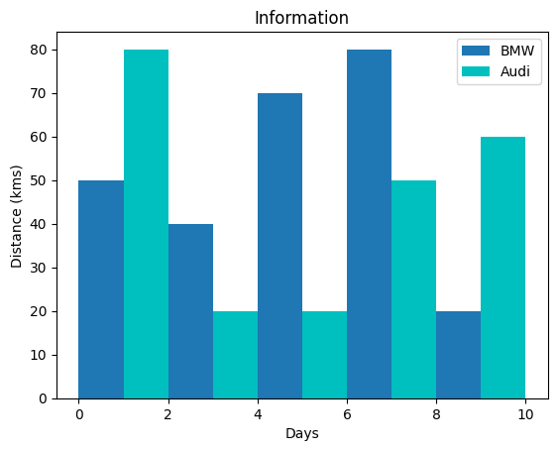 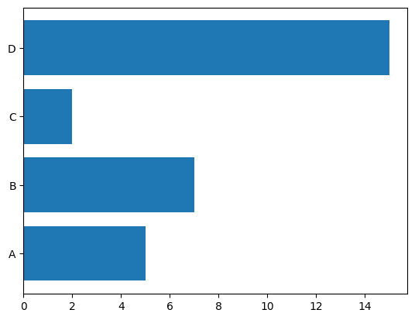 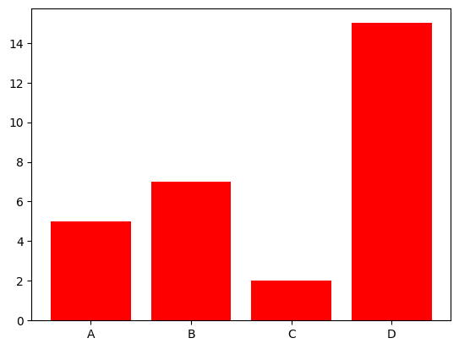 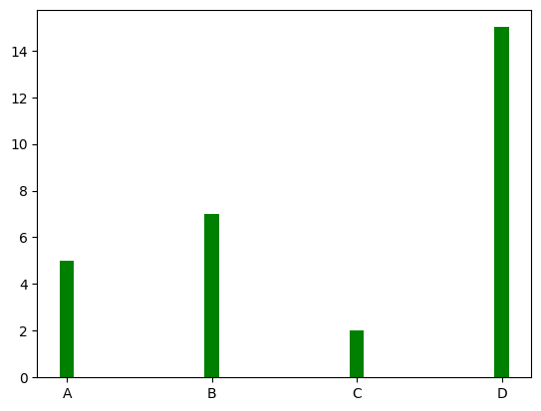 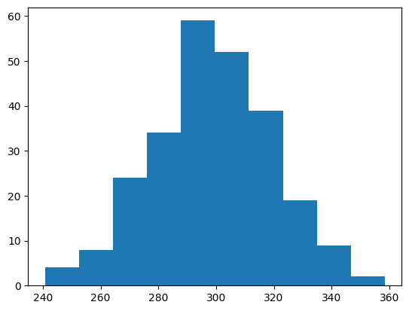 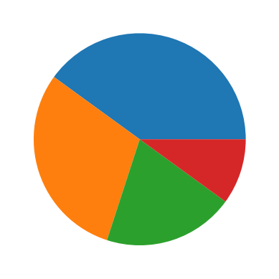 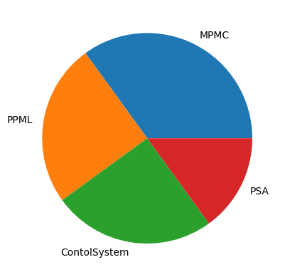 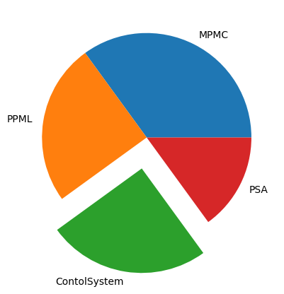

**DATA VIAUALIZATION-4**

**DESCRIPTION:**

1. Using seaborn package to do lineplot, scatterplot and barplot

2. Draw 3-D plot

3. Using plotly package to do scatterplot

**PROGRAM:**

**import** seaborn **as** sns

**import** matplotlib.pyplot **as** plt

**import** pandas **as** pd

**import** numpy **as** np

**import** plotly.express **as** px

*#seaborn package*

xpoints**=**np**.**array([0,20,120,200])

ypoints**=**np**.**array([10,80,100,120,150,180,250])

print(sns**.**scatterplot(data**=**ypoints))

print(plt**.**show())

print(sns**.**barplot(data**=**ypoints))

print(plt**.**show())

x**=**np**.**array([1,2,6,8,12,14,20])

y**=**np**.**array([3,8,1,10,12,16,18])

fig**=**plt**.**figure(figsize**=**(12,8))

ax**=**plt**.**axes(projection**=**'3d')

plt_3d**=**ax**.**scatter3D(x,y)

plt**.**colorbar(plt_3d)

plt**.**show()

*#plotly package*

c**=**np**.**array([10,80,100,120,150,180,250])

fig**=**px**.**scatter(x)

fig**.**show()

**OUTPUT:**

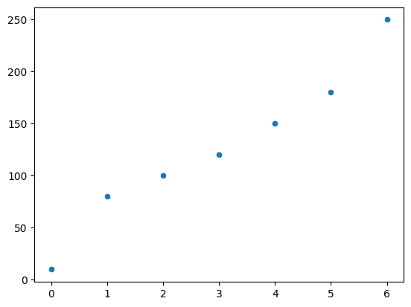 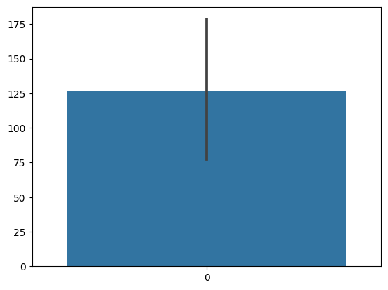 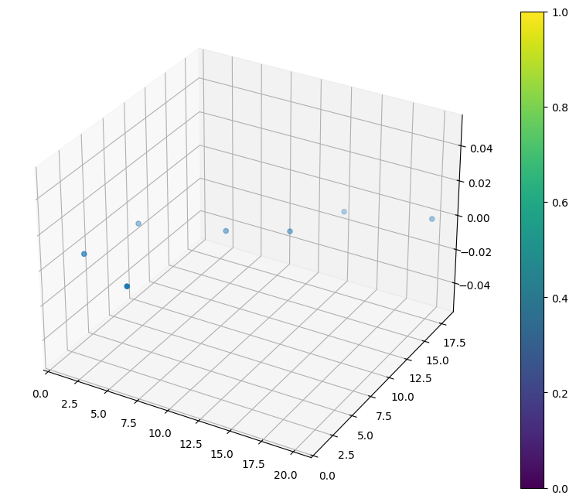

**Result:**

Thus data visualization was done by importing data visualization packages and doing basic functions.